EXP 2: Sketch a Simple Prototype of a Bus Ticket Booking System using Figma Tool

Step 1: Open Figma
- Open your browser.
- Go to Figma
- Sign in with your account.
- Click New Design File.
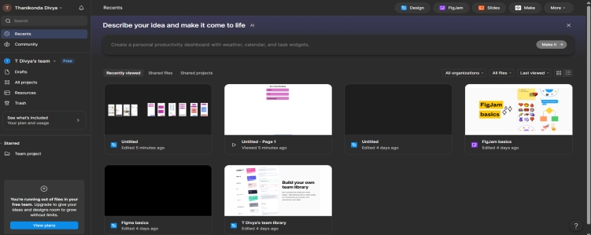

Step 2: Create the First Screen (Home Page)
2.1 Add Mobile Frame
- Press F on the keyboard.
- From the right panel select:
  - Phone
  - iPhone 14 (or any mobile frame)
2.2 Add Heading
- Press T (Text Tool).
- Click at the top of the frame.
- Type: Bus Ticket Booking System
2.3 Add Input Boxes
Press R (Rectangle Tool) and create 3 rectangles.
Label them:
- From
- To
- Journey Date
Example:
From: Chennai
To: Bangalore
Journey Date: 25-07-2026

2.4 Add Search Button
- Create another rectangle.
- Type inside: Search Buses

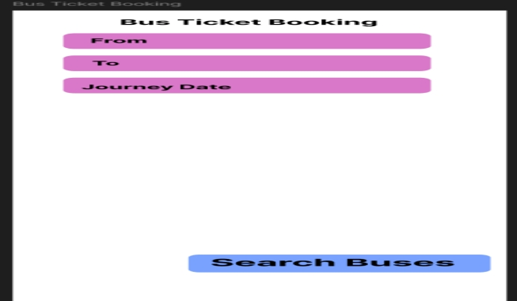

Step 3: Create Bus List Screen
3.1 Create New Frame
- Press F
- Create another mobile frame.
- Rename it: Bus List
3.2 Add Heading: Available Buses
3.3 Create Bus Cards
Create rectangles for buses.
Bus 1
ABC Travels
Departure: 09:00 AM
Fare: ₹700
[ Book Now ]
Bus 2
XYZ Travels
Departure: 11:00 AM
Fare: ₹850
[ Book Now ]

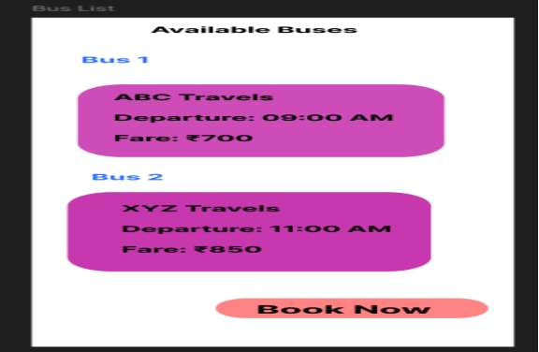
Step 4: Create Seat Selection Screen
4.1 Create New Frame
Create another mobile frame.
Title: Select Your Seat
4.2 Draw Seats
Use small rectangles.
Example:
[A1] [A2]
[A3] [A4]
[B1] [B2]
[B3] [B4]
4.3 Color Seats
Seat Status | Color
Available | Green
Booked | Red
Selected | Blue

4.4 Add Continue Button: Continue
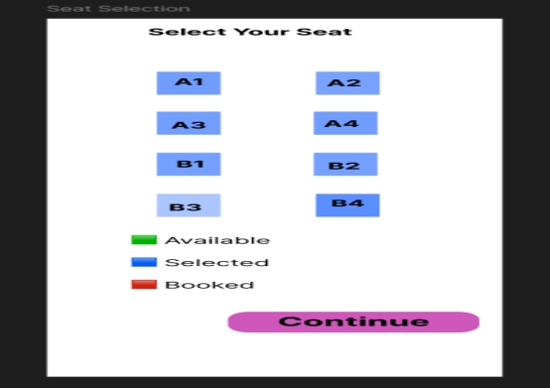
Step 5: Create Passenger Details Screen
Create a new frame.
Title: Passenger Details
Add Input Fields
Passenger Name
Age
Gender
Mobile Number
Add Button
Proceed to Payment
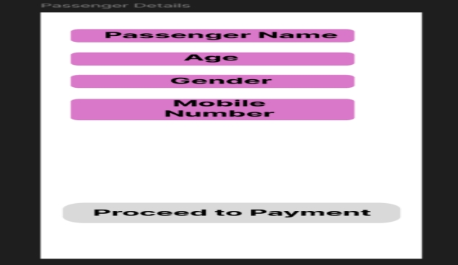

Step 6: Create Payment Screen
Create another frame.
Title: Payment Add Information
Ticket Fare: ₹700
Select Payment Method
○ UPI , Debit/Credit Card , Net Banking

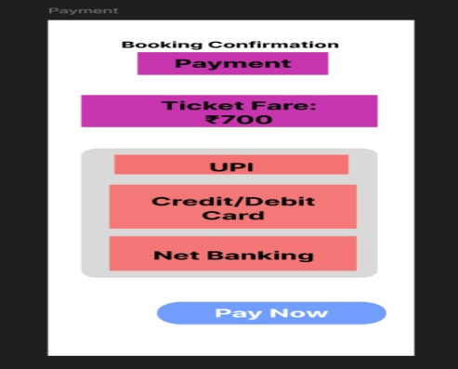

Step 7: Create Confirmation Screen
Create the final frame.
Title: Booking Confirmation
Add Confirmation Details
✓ Booking Successful
Ticket Number: BUS12345
Seat: A2
Route: Chennai → Bangalore
Add Button: Download Ticket

